Password handling in sqoop using –P

Tables in sql

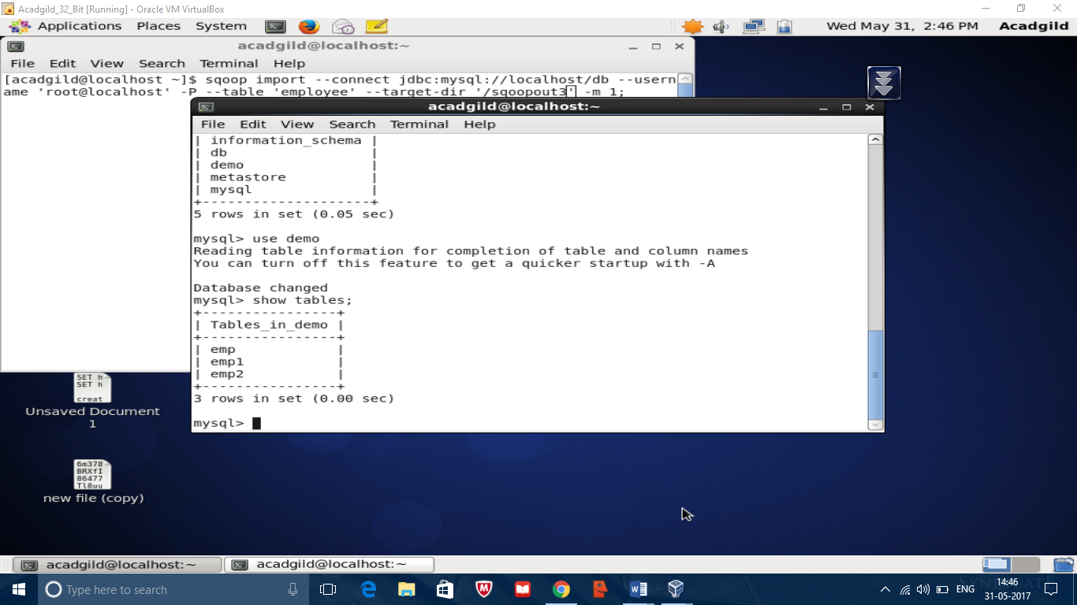

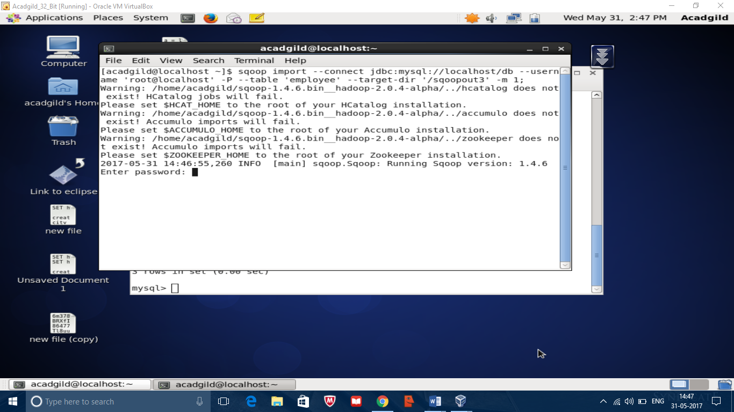

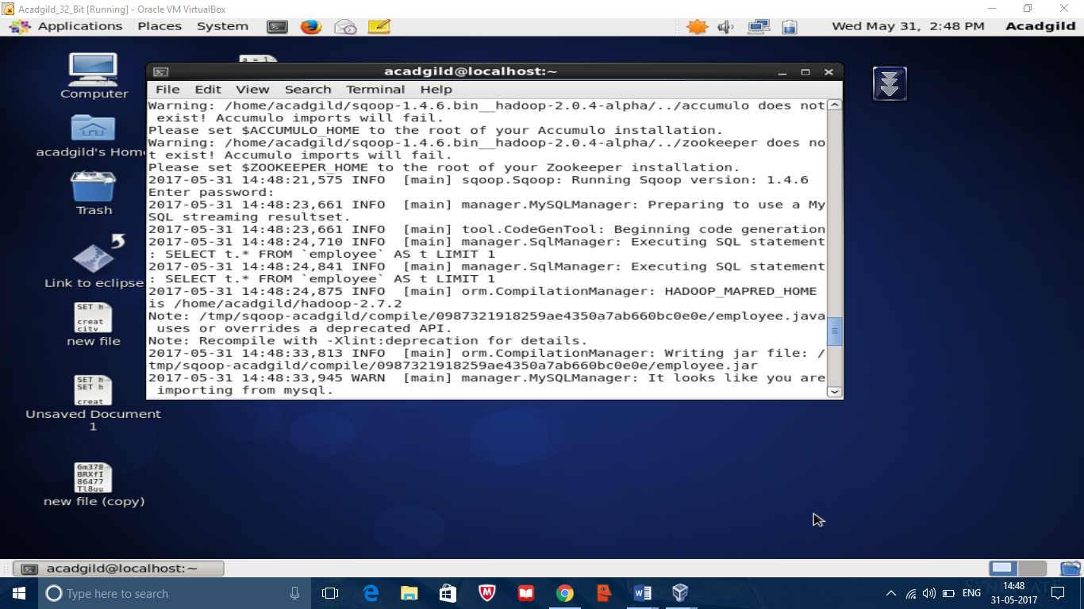

Completion of sqoop import

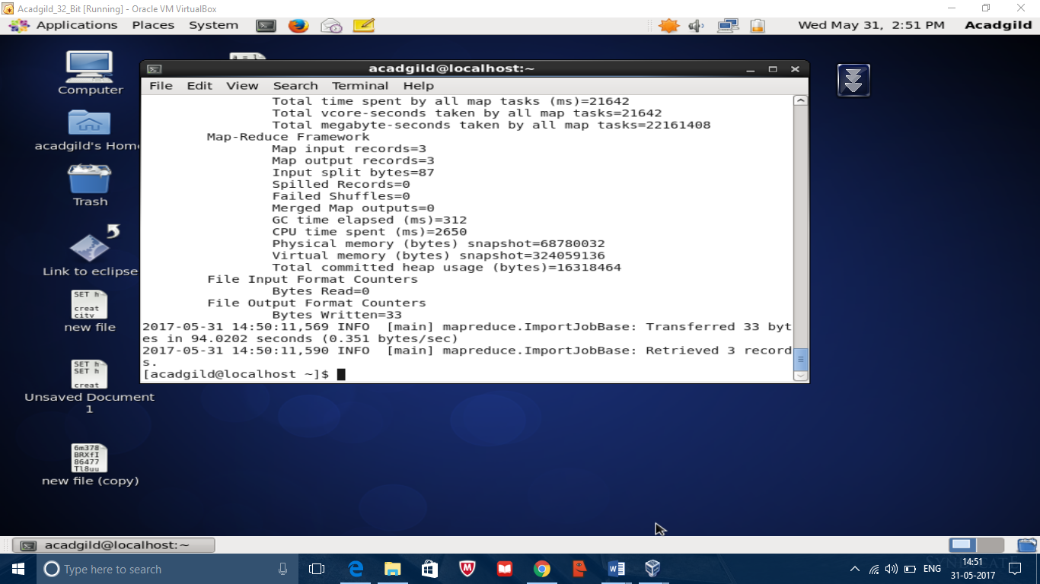

Output

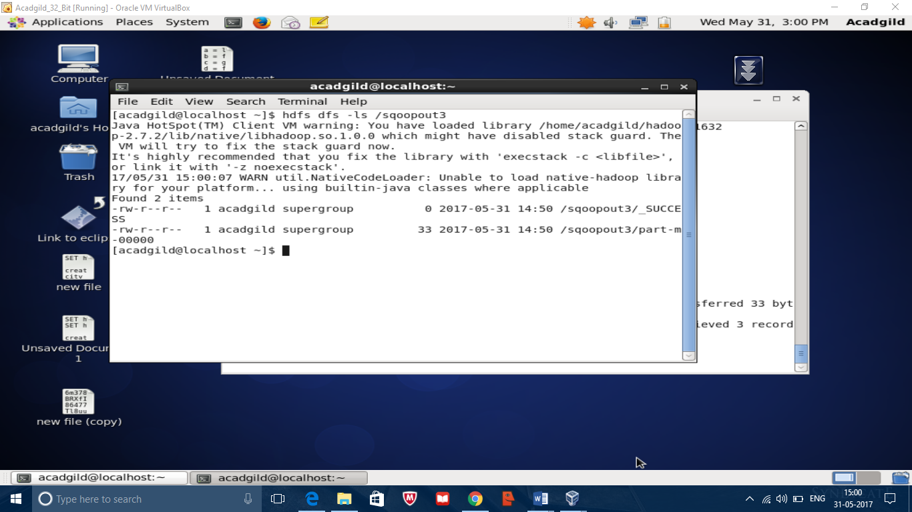

Sqoop with –password-file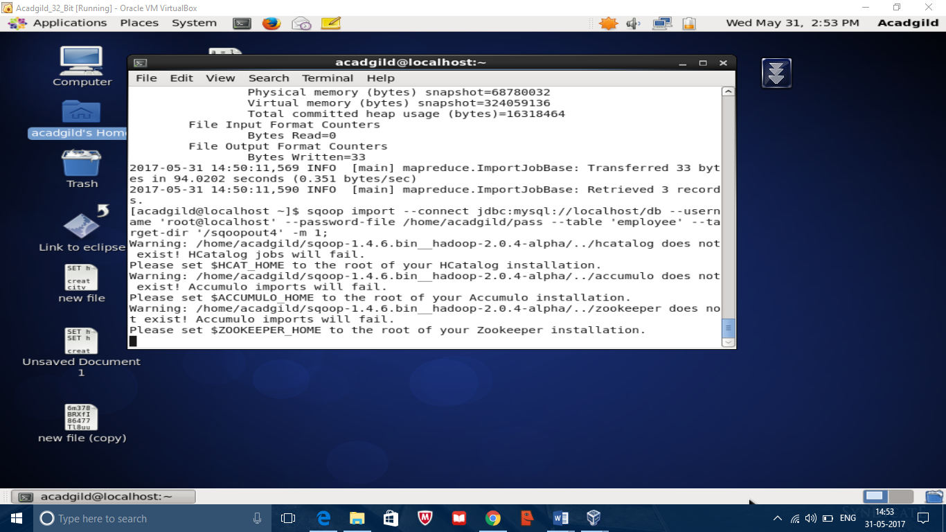

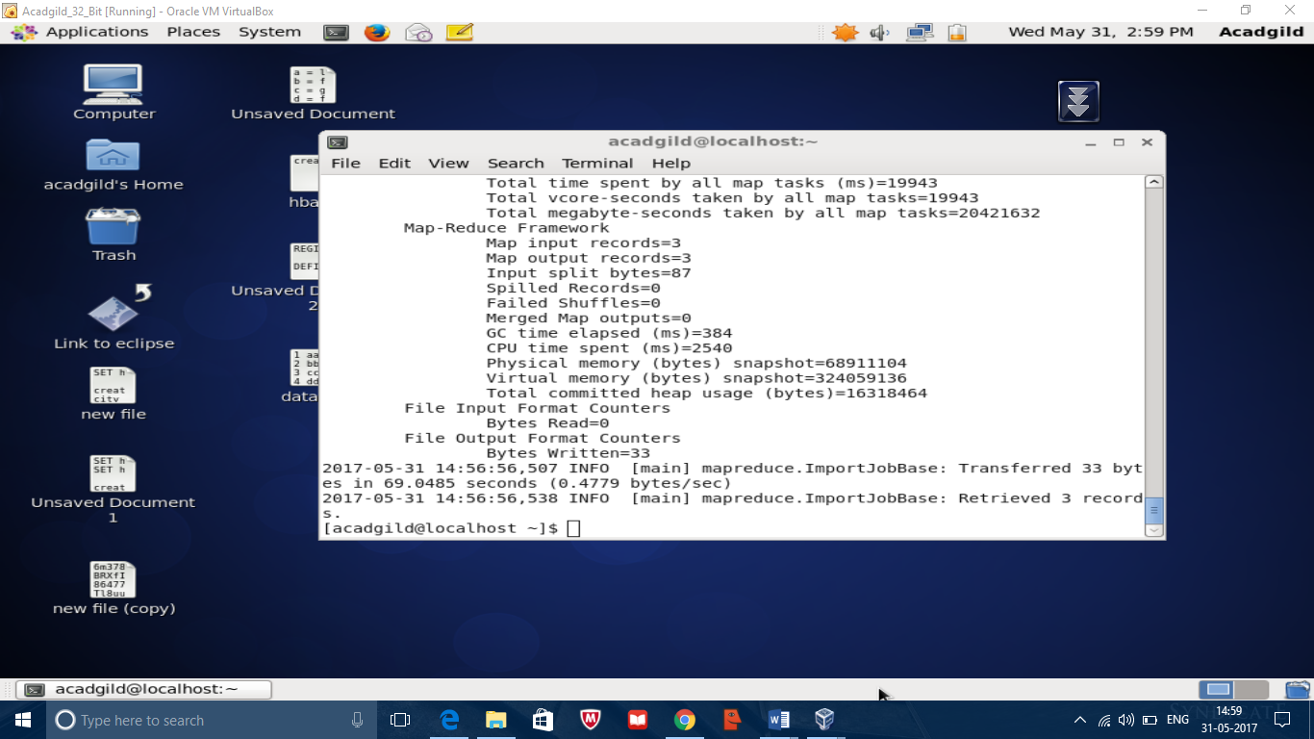

Output

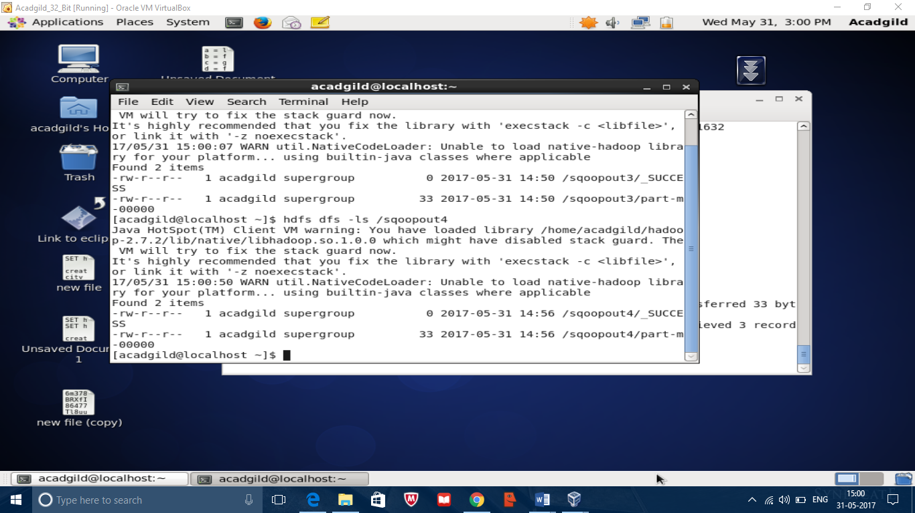

Speed transfer

Sqoop can handle bulk transfer very well. The speed of the transferring can be increased by using –direct parameter which uses the native utility of the database provider in mysql mysqldump and mysqlimport are used for data transfers between mtsl and sqoop this is called as the speed transfer

Table emp is used for speed transfer



Sqoop speed transfer

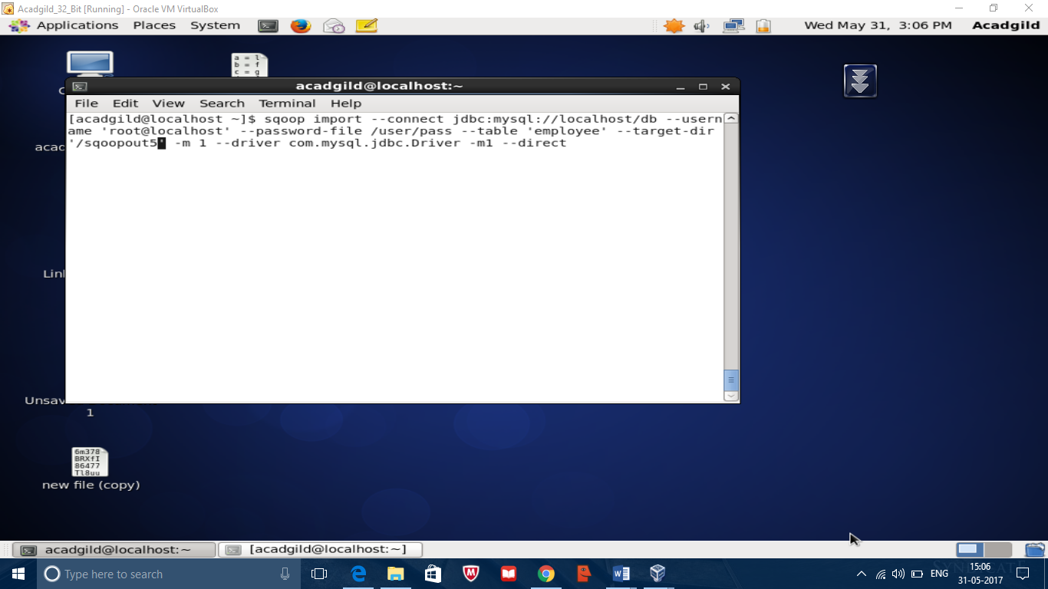

Completion of map reduce execution

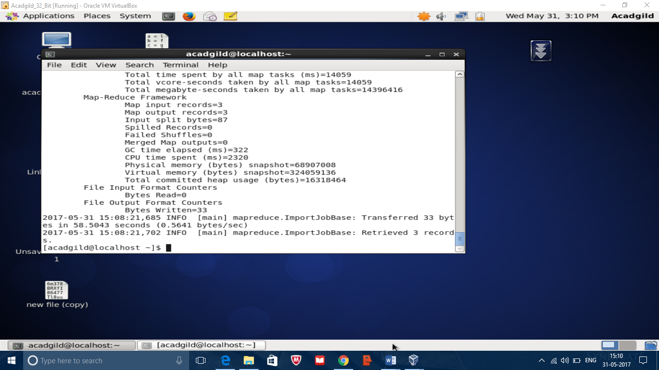

Output

